**Problem Statement: Socket Programming in C**

**Design and implement a reliable and efficient network communication system using socket programming in C to enable data exchange between two or more processes running on different machines over a network.**

**Specific Requirements:**

**Socket creation: Create appropriate socket descriptors for the desired communication protocol (TCP, UDP, etc.).**

**Address binding: Bind the created socket to a specific network address and port number for both client and server applications.**

**Connection establishment: Implement connection setup mechanisms (connect, accept) for TCP-based communication.**

**Data transfer: Develop functions for sending and receiving data over the established socket connection.**

**Error handling: Incorporate robust error handling mechanisms to address potential network issues and unexpected exceptions.**

**Concurrency: For server-side applications, consider handling multiple client connections concurrently using appropriate techniques (e.g., threading, forking).**

**Security: Implement appropriate security measures to protect data integrity and confidentiality (e.g., encryption, authentication).**

**Login authentication from Client to server 1:**

**Server:**

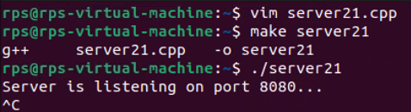

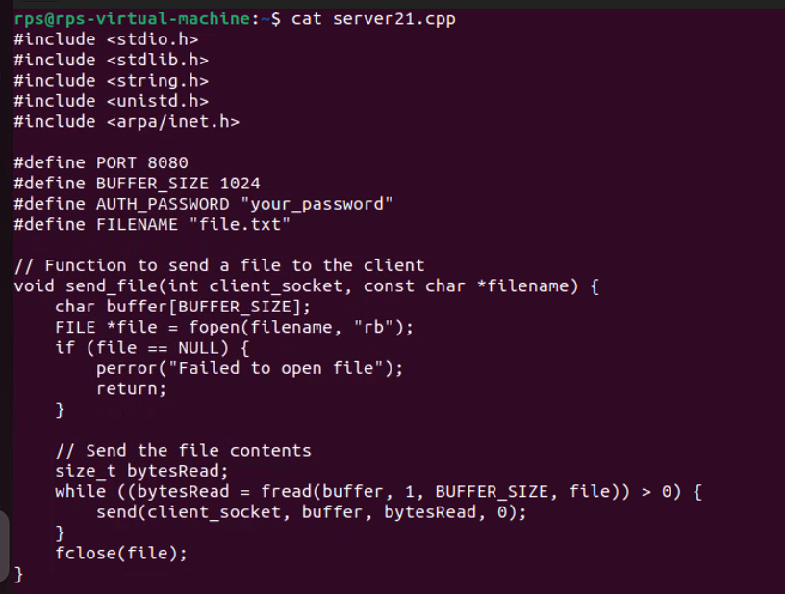

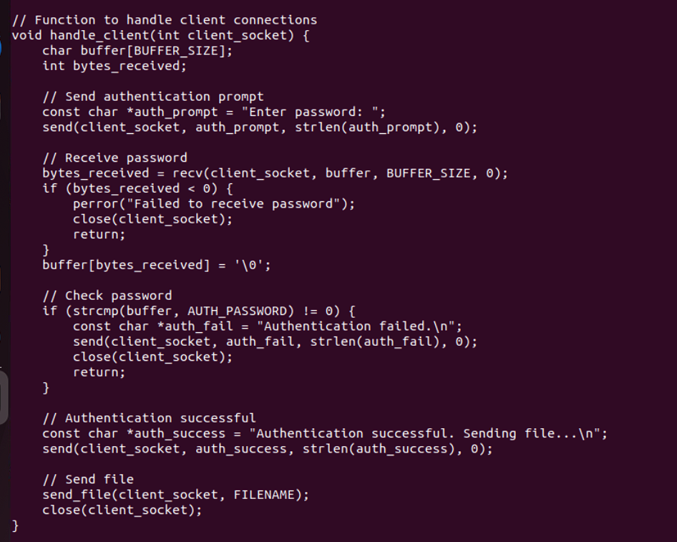

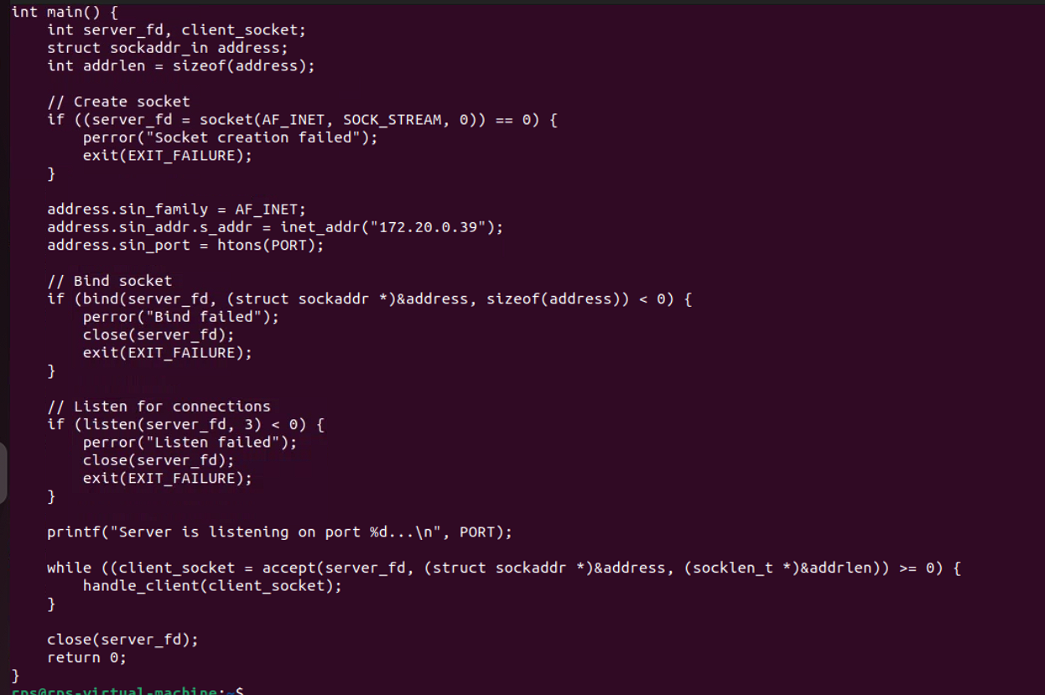

**Client:**

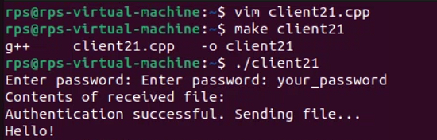

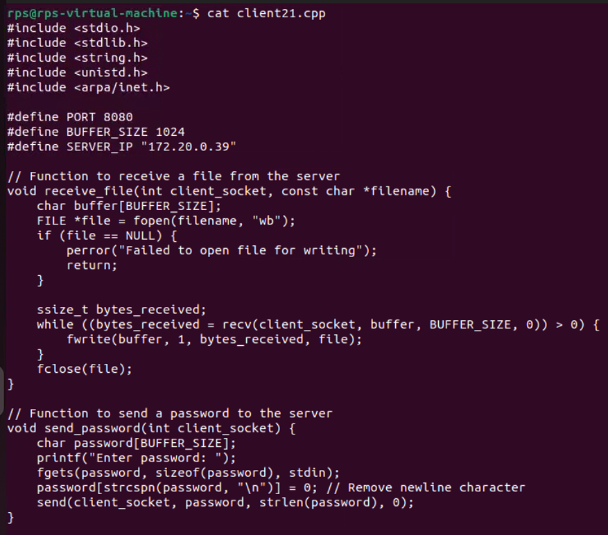

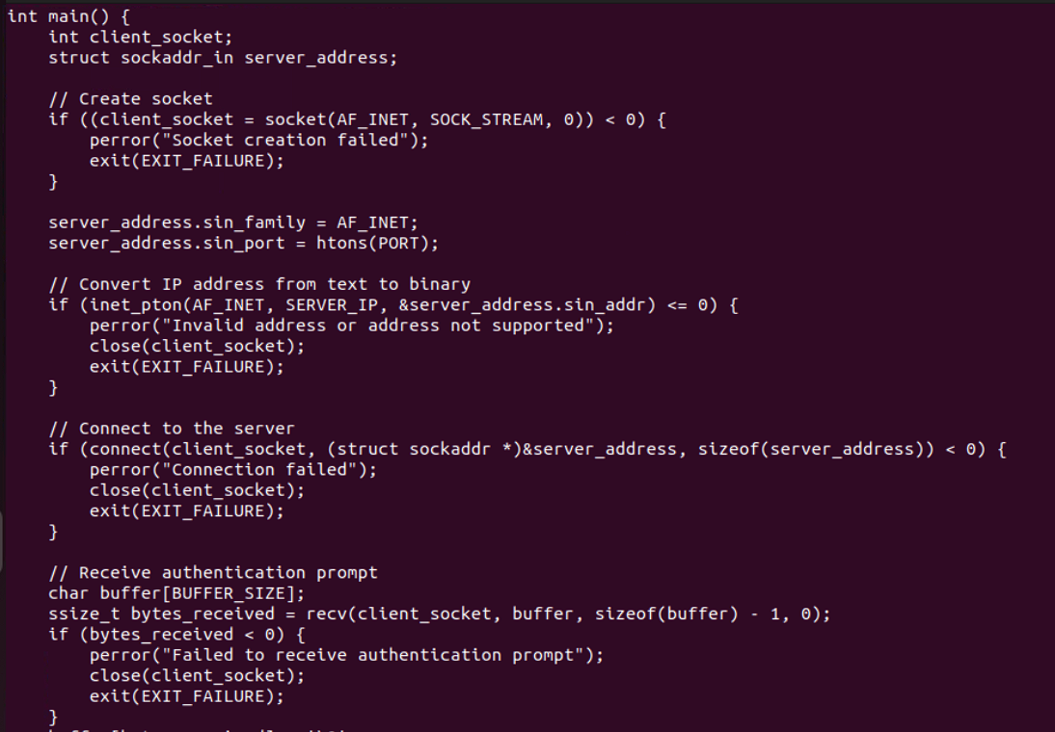

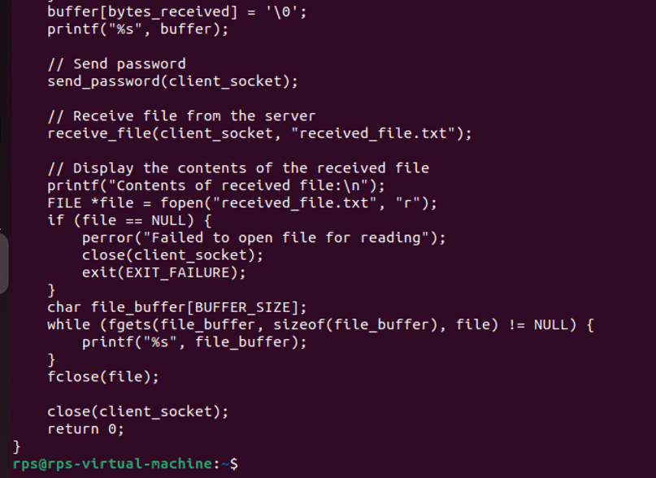

**From Client to server 2:**

**Server:**

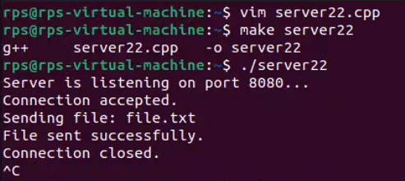

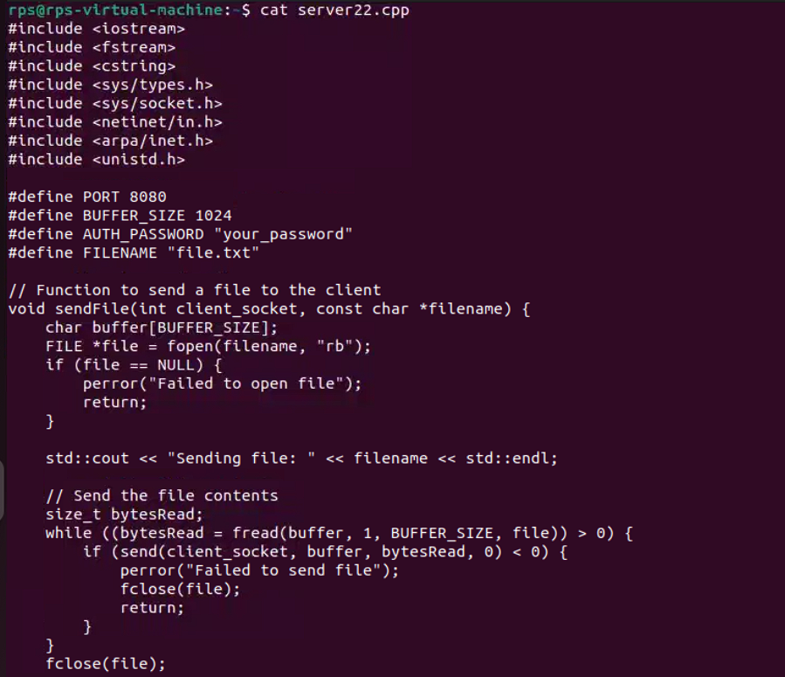

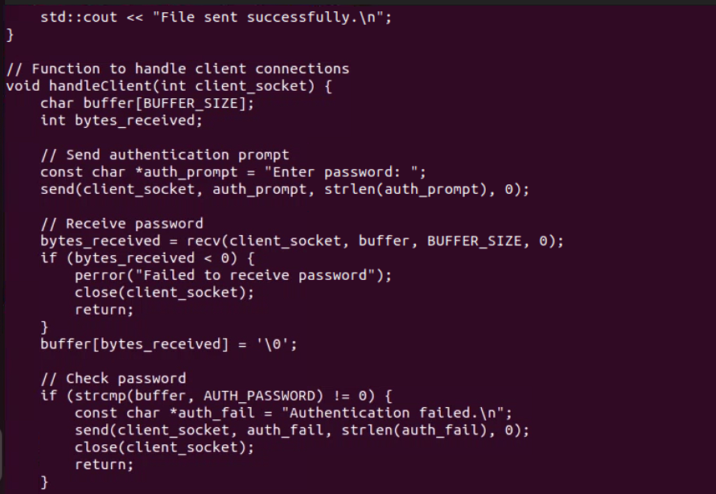

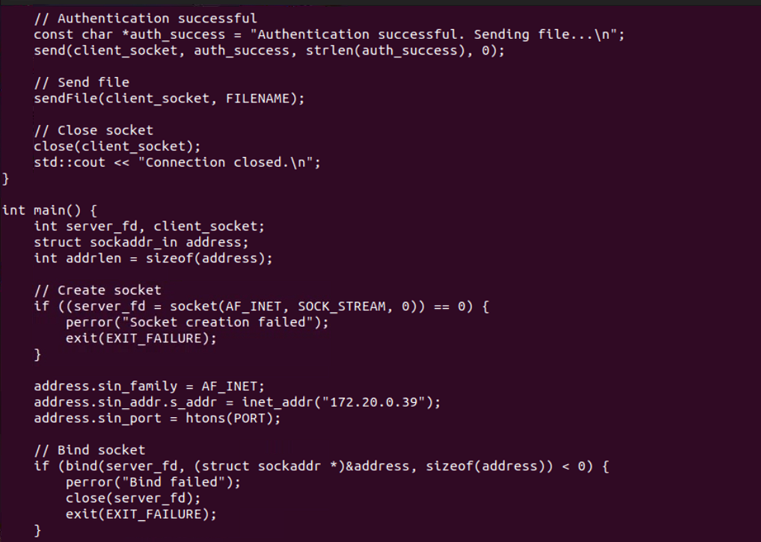

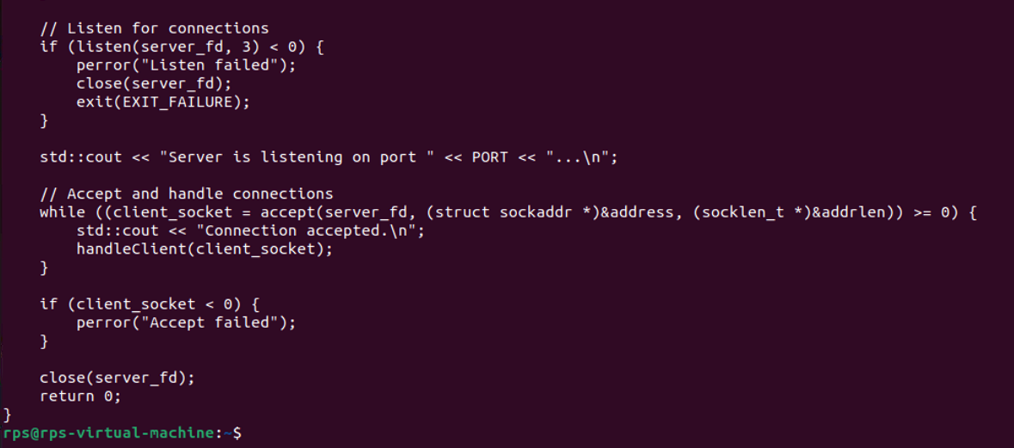

**Client:**

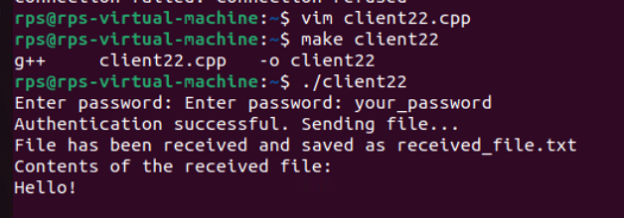

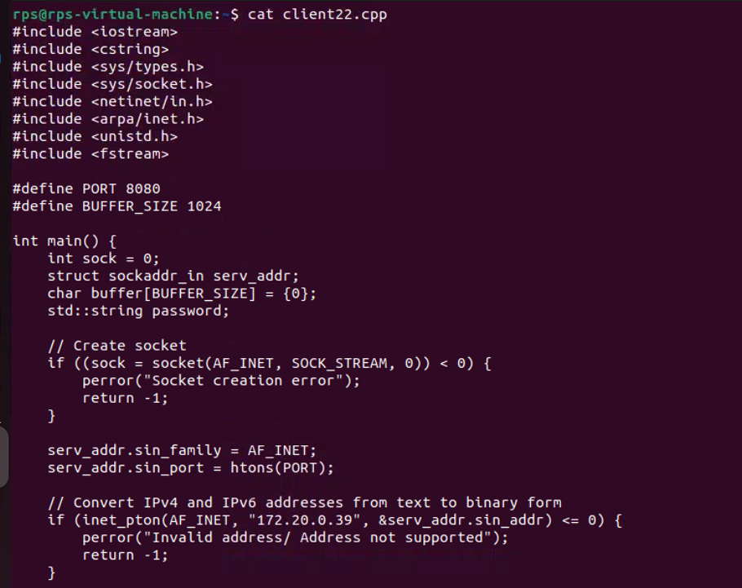

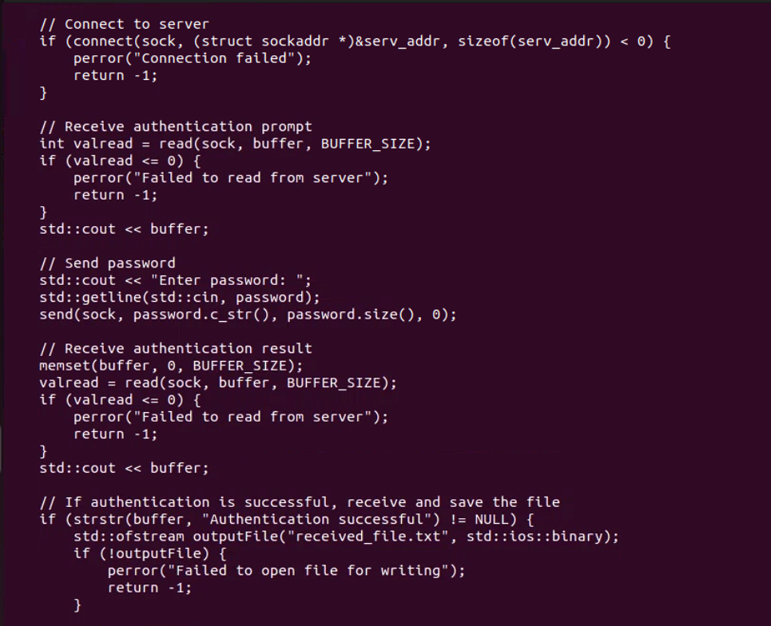

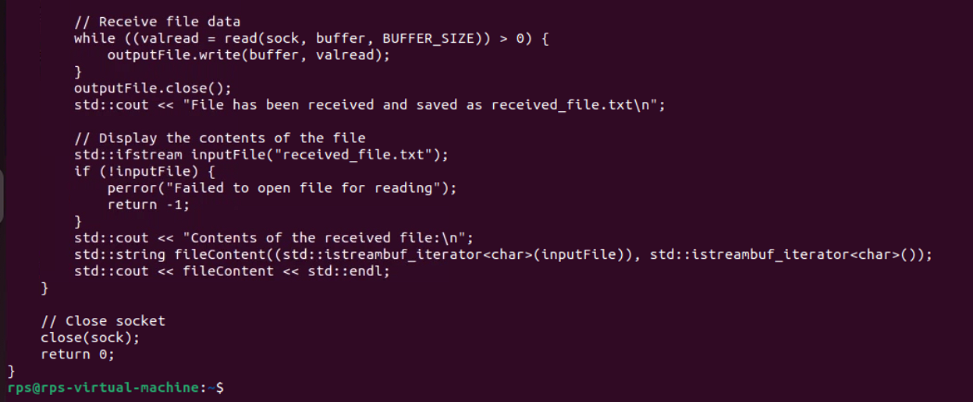

**Server – client  
Server**

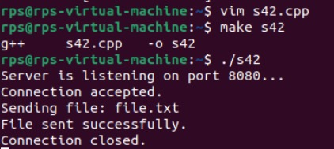

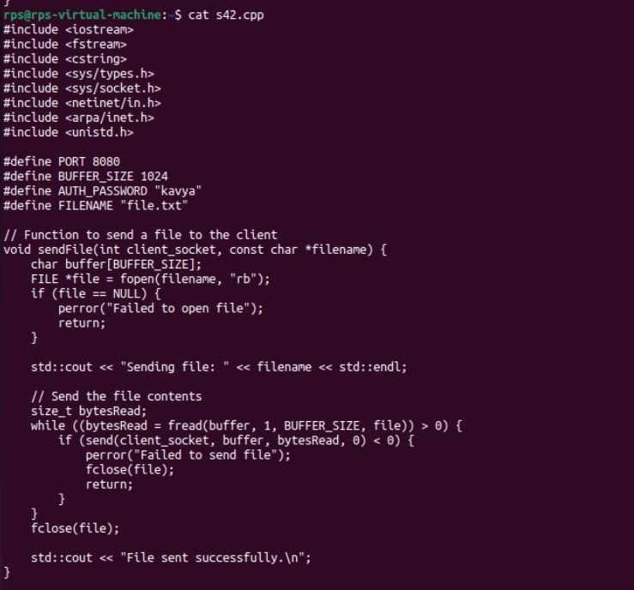

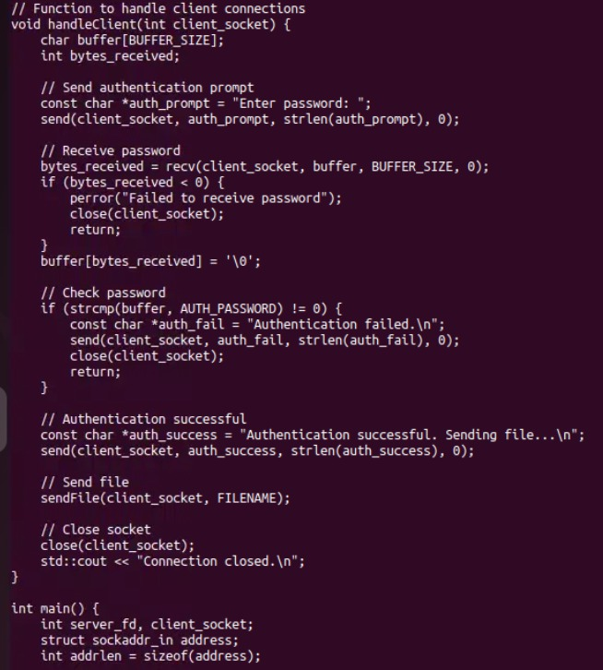

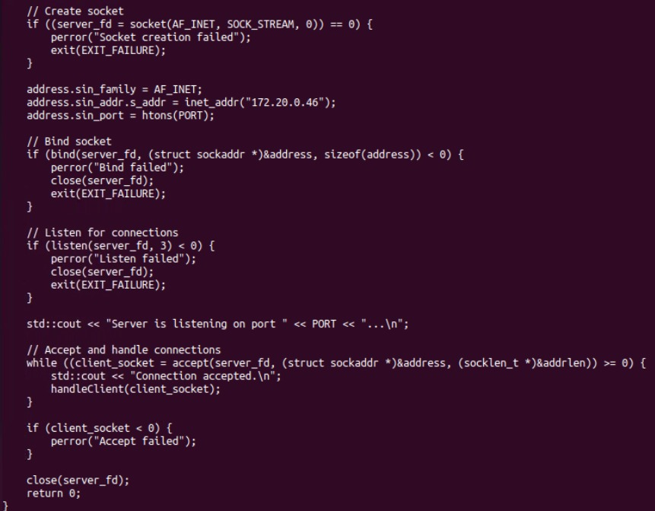

**Client**

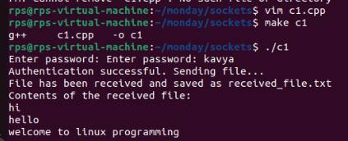

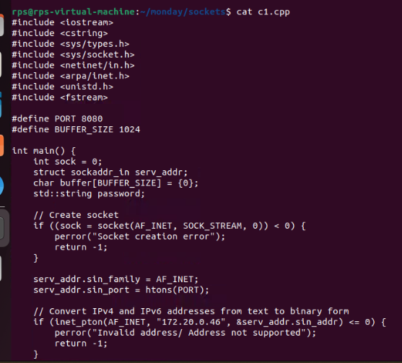

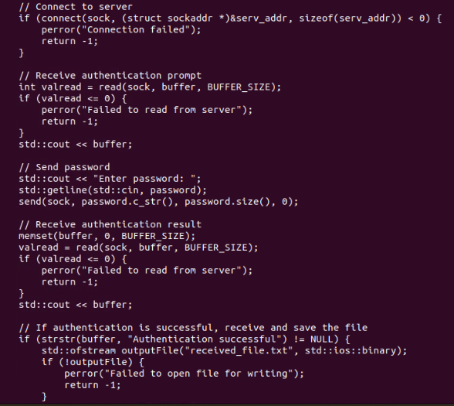

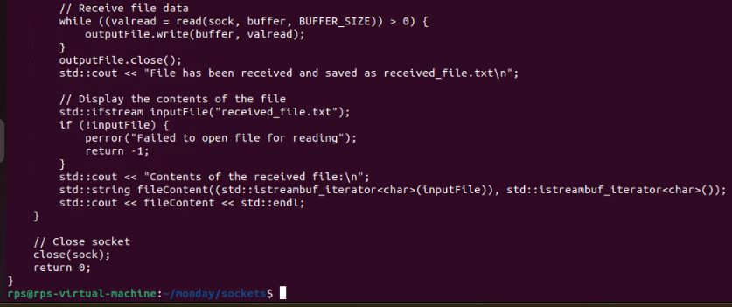

**Sending Message to server to client within a system**

**IPC (Inter process communication):**

**Server:**

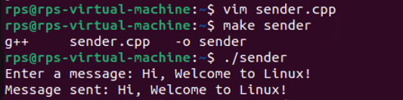

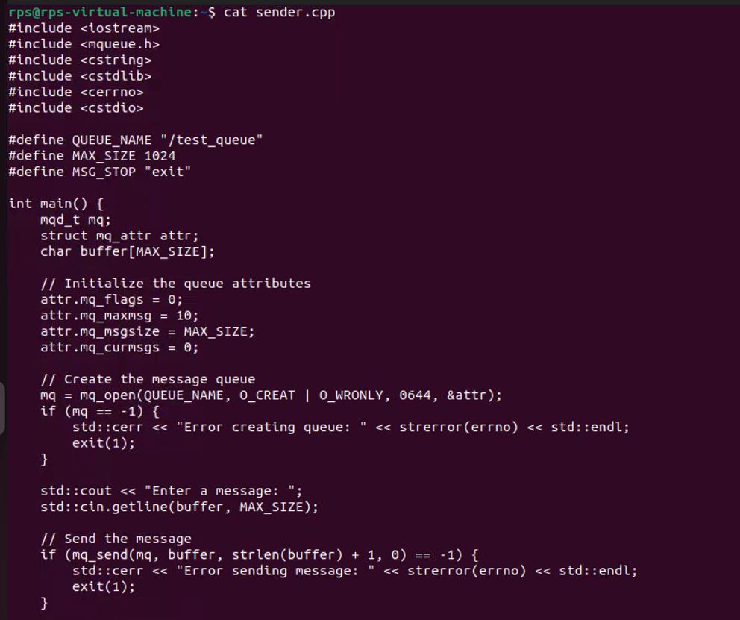

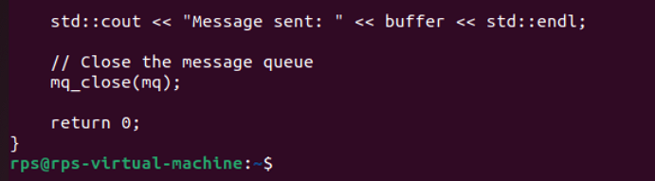

**Client:**

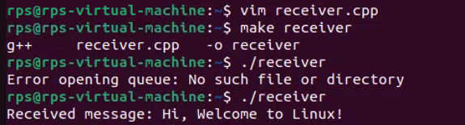

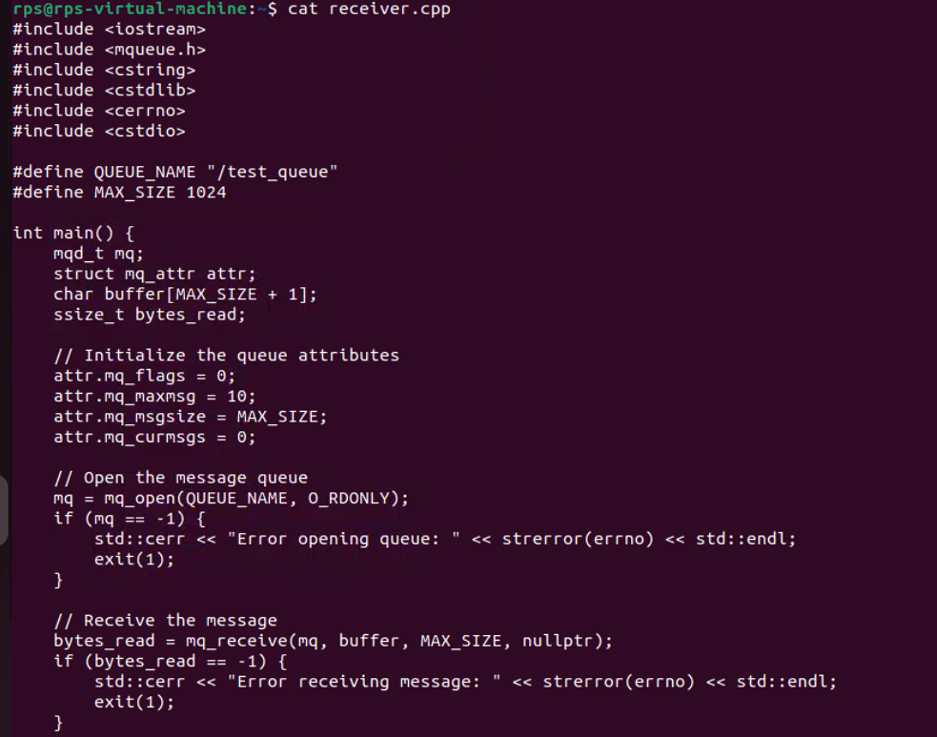

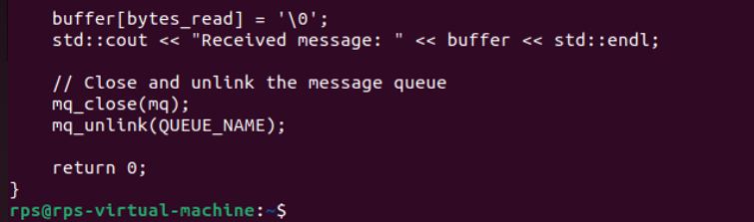

**Message Queue:**

**Server:**

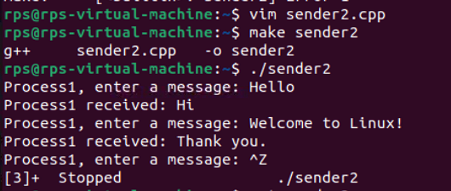

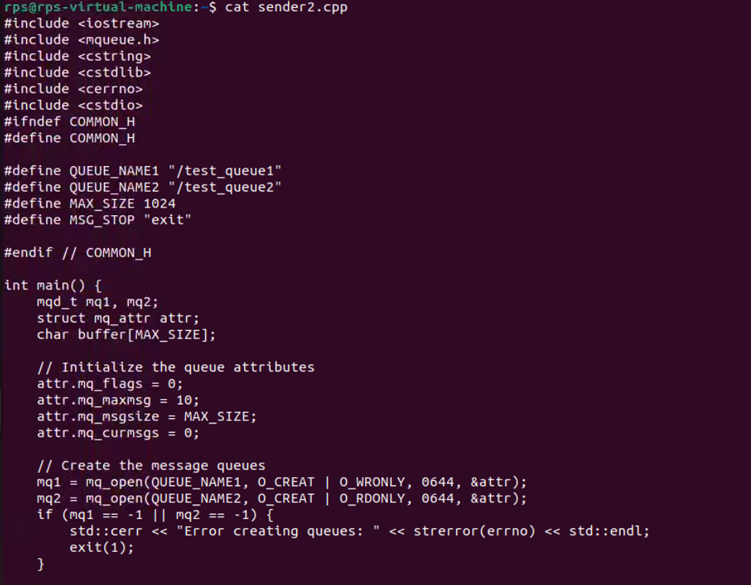

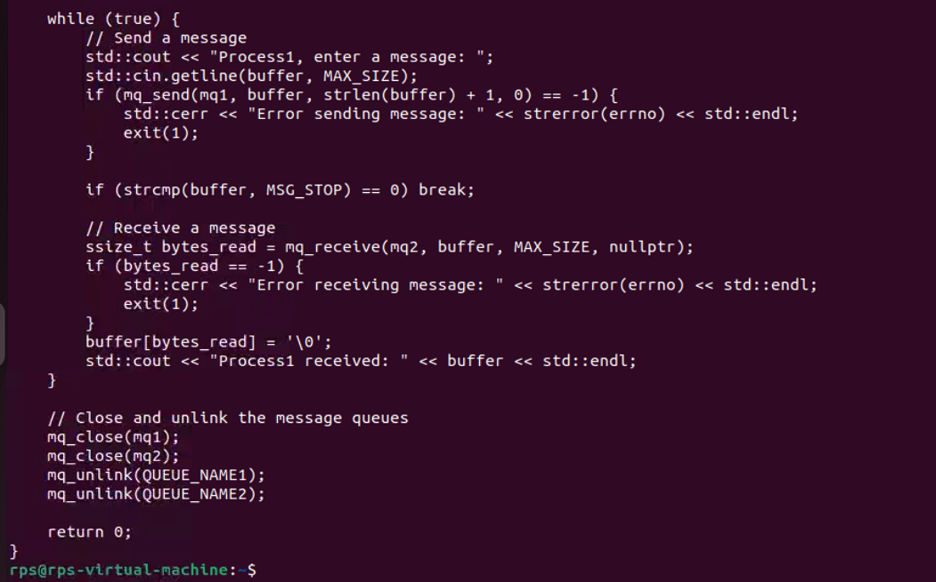

**Client:**

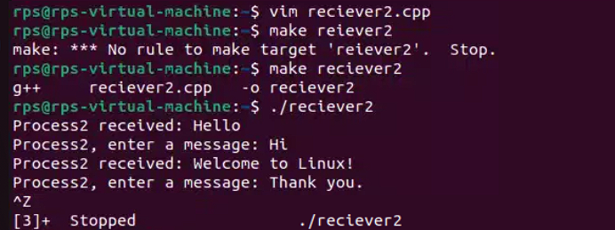

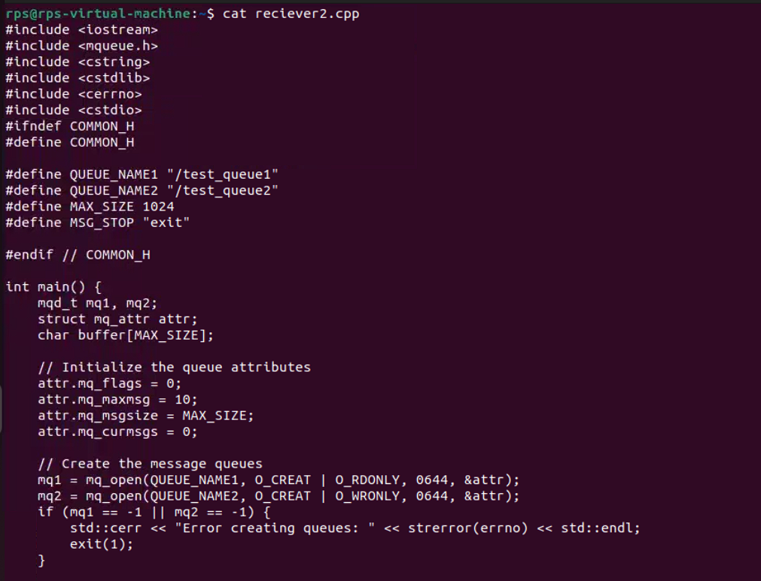

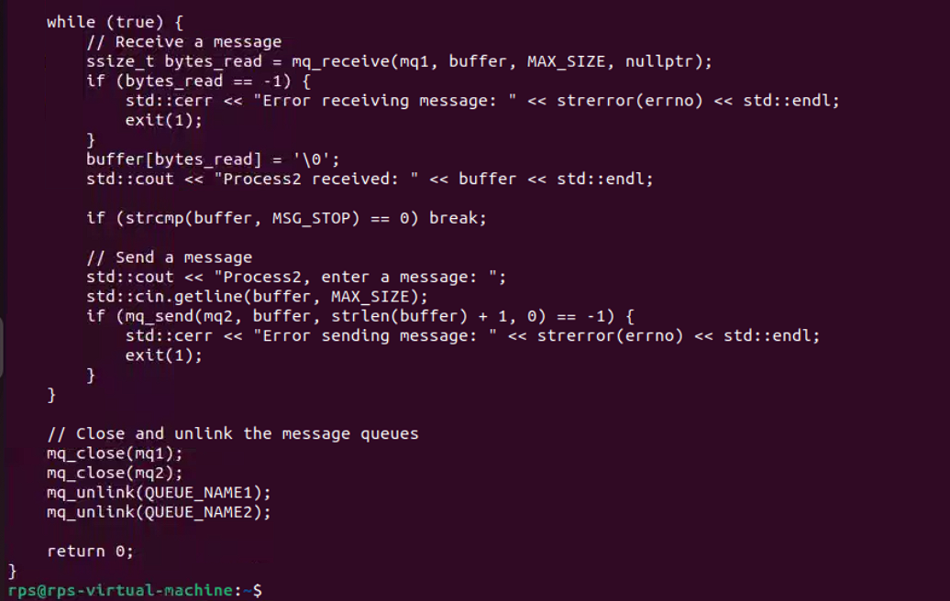

#include <iostream>

#include <unistd.h>

#include <sys/wait.h>

using namespace std;

int main() {

pid_t pid = fork();

if (pid < 0) {

cerr << "Fork failed" << endl;

return 1;

} else if (pid == 0) { // Child process

// Replace the current process with the "ls" command

execl("/bin/ls", "ls", "-l", nullptr);

cerr << "Exec failed" << endl; // This line won't be reached if execl is successful

return 1;

} else { // Parent process

// Wait for the child process to finish

wait(nullptr);

cout << "Child process completed" << endl;

}

return 0;

}

OUTPUT:

